Software Requirements Specification
CS684 Projects

Visual Programming for Firebird V

Group 8

Akshar 09305909
Shweta 10305914

Table of Contents

1 Introduction 3
1.1 Scope Error! Bookmark not defined.
1.2 Definitions, Acronyms and Abbreviations 3
1.3 References 3
2 Overall Description 3
3 Details 3
3.1 Functionality 3
3.2 Supportability 3
3.3 Design Constraints 4
3.4 On-line User Documentation and Help System Requirements 4
3.5 Interfaces 4
3.5.1 User Interfaces 4
3.5.2 Hardware Interfaces 4
3.5.3 Software Interfaces 4
3.5.4 Communications Interfaces 4

Introduction
Our project aims at developing a visual programming environment for Firebird V. This visual programming environment is highly inspired from MIT’s scratch. This document describes the requirements of this project in detail.

Definitions, Acronyms and Abbreviations

- SCRATCH: MIT’s visual programming language
- Firebird V: We refer to ATMEGA2560 based firebird V architectures unless mentioned otherwise.
- Blocks: Elements of visual programming.
- Workspace: Area where visual program will be designed.
- Sensors: input devices on firebird V.
- Actuators: Output devices on firebird V.
- OpenBlocks: API provided by MIT to create visual programming environment.
- Netbeans: IDE we use.

References
- SCRATCH: http://info.scratch.mit.edu/Research
- OpenBlocks: http://education.mit.edu/drupal/openblocks

Overall Description

The core idea of the projects is that a user can simple drag and drop colorful blocks to describe the logic with which the robot must work. Our software provides this workspace to the user. Once done user can chose to download the C Program that is represents this visual program.

Project Perspective

Our product deliverable will be a java program. This will provide blocks to be dragged and connected in the workspace area. One user is done he will click a save button which will save a C program on the hard-disk that will be the equivalent of the visual program. This c program can directly compiled an burned on Firebird using AVR Studio.

Product Functions

- XML File that describes what all blocks can be used in visual programming.
- Workspace to design visual programs using these predefined blocks.
- Converting visual program to XML equivalent.
- C program to convert XML to firebird compliant C program.

Constraints

- We are limiting the actuator and sensors to Motion control, Buzzer, White-line and front IR sensors only.

Details

Functionality

This section describes all the functionality in detail.

Supportability

- Firebird V ATMEGA2560 architecture only is supported.
- Application will run on JRE 1.6 and above.

Design Constraints

- Complex things such as variable creation and procedure creation is too complicated to implement hence it will not be implemented.

On-line User Documentation and Help System Requirements

- Openblocks JavaDocs will be provided
- The C Program generated will have documentation generated using Doxygen.
- A PDF document describing the internal XML-parsing an Block definitions.

Interfaces

User Interfaces

An IDE to write visual programs. Mockup presented here.
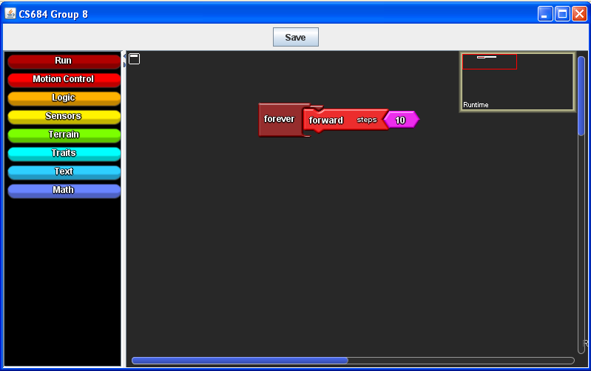

Saving C program that represents the Visual Program.
As per above screenshot the generated program might look like
void main()
{
while(1)
{
move_fwd(10);
}
}

Winavr_firebird.h files that implements functions to access sensors and actuate the actuators.
In the given screenshot. This file will contain the implementation of move_fwd

Hardware Interfaces
- Our project does not use any hardware interfaces besides the standard firebird ATMEL MKL programmer to program the robot.

Software Interfaces
- Lang-def XML file that defines all the fundamental blocks used for visual programming
- Codeblocks API that parses this XML file.
- WorkspaceController Interface that converts Visual Program to XML.
- C program to convert that XML to C Program.

Communications Interfaces
Not Applicable.

